UDHNA CITIZEN COMMERCE COLLEGE & S.P.B COLLEGE OF BUSINESS
ADMINISTATRATION & SMT.DIWALIBENHAR GONDALIA COLLEGE OF BCA AND I.T.
Bachelor of computer application (BCA) Programme


Minor Project Report
BCA Sem – 5
Year: 2025 -2026
Class: TYBCA - F
Group no. – WFS_A209

Project Title: Online Voting System
Submitted By
Roll No. | Name of student
2548008 | Devendra P Sonawane
2548032 | Shivam Das
2548005 | Dipika M Yadav

Project Guided By: -
• Prof.

INDEX
Chapter No. | Chapter Name | Page No.
1. | Introduction
2. | Limitation of Existing system
3. | Objectives
4. | Scope
5. | Advantages
6. | System Design
7. | Teck Stack
8. | Screenshots
9. | Coding
10. | References

1. Introduction
Coffee has always been more than just a beverage; it is a culture, a daily ritual, and for many, an essential part of their lifestyle. Over the years, coffee consumption has evolved from traditional homemade brews to modern, specialized coffee shop experiences. Starbucks, a global leader in the coffee industry, has set a benchmark by offering high-quality coffee beverages, a wide variety of menu options, and a consistent customer experience across its outlets worldwide.
In today’s fast-paced world, convenience has become a crucial factor for customers. They expect quick service, personalized experiences, and the ability to access products anytime, anywhere. Traditionally, coffee shop operations rely on manual processes where customers physically visit the store, wait in line, and place their orders. While this approach works, it often leads to inefficiencies such as long queues, incorrect orders due to miscommunication, and delays during peak hours. Moreover, keeping track of customer preferences and order history becomes challenging when everything is done manually.
To address these issues, there has been a growing need for digital transformation in the coffee shop industry. Many businesses, including Starbucks, have started integrating technology into their operations to streamline processes and enhance customer satisfaction. A digital ordering system not only speeds up service but also provides valuable insights to store managers and improves inventory and sales tracking.
The Starbucks Coffee Shop Ordering System project is a step toward modernizing the coffee ordering process by offering a web-based platform that simplifies interactions between the coffee shop and its customers. This system allows customers to browse the Starbucks menu, select their desired beverages, customize their orders, and place them online with ease. By introducing features such as user registration, secure login, and order history tracking, the system ensures a personalized and secure experience for every customer.
From the perspective of the coffee shop management, this system provides tools to manage menu items, view active and past orders, and analyze customer trends. By digitizing these tasks, the coffee shop can reduce manual workload, minimize errors, and improve overall operational efficiency.
This project is developed using PHP for backend development, MySQL for database management, and HTML, CSS, and JavaScript for the frontend interface. The choice of these technologies ensures that the system is lightweight, scalable, and easy to maintain. The database securely stores all essential data, including customer information, menu details, and order transactions, enabling quick and accurate data retrieval whenever needed.
The system has been designed with a user-centric approach, keeping in mind both customer convenience and business requirements. It allows Starbucks customers to experience the same quality service online as they would receive at a physical store. Additionally, the platform sets the foundation for integrating advanced features in the future, such as online payment gateways, delivery tracking, and loyalty programs.
In summary, the Starbucks Coffee Shop Ordering System aims to:
- Enhance the customer experience by providing a fast and easy ordering process.
- Reduce errors and improve efficiency through automation.
- Offer a centralized platform for order and customer management.
- Provide detailed insights into customer behaviour and sales trends.
By implementing this system, Starbucks can continue to lead the coffee industry in innovation and customer service, meeting the demands of modern consumers while optimizing its operational workflow.

S No. | Chapter | Topic | Page No.
1. | Chapter 1 | Introduction
 | 1.1 | Project Overview
 | 1.2 | Problem Statement
 | 1.3 | Project Goals and Objectives
 | 1.4 | Scope of the Project
2. | Chapter 2 | Limitation of Existing System
3. | Chapter 3 | Objectives
4. | Chapter 4 | Scope
5. | Chapter 5 | Advantages
6. | Chapter 6 | System Design
 | 6.1 | Database Design
7. | Chapter 7 | Screenshots
8. | Chapter 8 | Coding
9. | Chapter 9 | References

Chapter 1: Introduction
1.1 Project Overview
The Cafe Management System is a comprehensive, full-stack web application designed to streamline and modernize the operations of a cafe. It provides a digital platform for managing sales, orders, menus, and staff, enhancing both customer experience and administrative efficiency.
Built with the powerful CodeIgniter 4 framework for PHP, the system features a robust backend and a dynamic, user-friendly frontend. It caters to multiple user roles, each with a tailored interface and specific functionalities:
- Admin: Has complete oversight of the system, including managing menu items, categories, staff, and tables, as well as viewing sales reports and configuring cafe settings.
- Chef: Can view incoming orders in real-time on a dedicated dashboard and update their status (e.g., from 'Pending' to 'In Making' or 'Completed').
- Cashier: Manages the point-of-sale, creating new orders for both dine-in and take-away customers, and viewing sales data.
- Guests/Customers: Can browse the menu and place orders directly through the system.
The vision of this project is to create an efficient, reliable, and easy-to-use platform that automates key cafe operations, reduces manual errors, and provides valuable insights into the business's performance.
1.2 Problem Statement
Traditional cafe management often relies on manual processes that are inefficient and prone to errors:
- Manual Order Taking: Taking orders by hand can lead to mistakes, miscommunication between the front-of-house and the kitchen, and slower service.
- Inefficient Kitchen Workflow: A lack of a clear, real-time system for the kitchen to view and manage incoming orders can cause delays and confusion.
- Difficult Sales Tracking: Manually tracking daily sales is tedious and makes it challenging to generate insightful reports for business analysis.
- Lack of Centralized Management: Without a unified system, managing the menu, tracking table availability, and overseeing staff is a fragmented and time-consuming process.
This project aims to solve these problems by providing a centralized digital solution.

1.3 Project Goals and Objectives
The primary goal is to develop a comprehensive Cafe Management System. This is broken down into the following key objectives:
- To Develop a Secure Multi-Role System:
  - Implement a robust authentication system to manage access for different user roles (Admin, Chef, Cashier).
  - Use filters to ensure that users can only access the functionalities relevant to their role.
- To Build an Intuitive and Responsive User Interface:
  - Design a clean and user-friendly interface using Bootstrap 5 that works seamlessly across various devices.
  - Create dedicated dashboards for each user role to provide them with the specific tools they need.
- To Create a Comprehensive Order and Menu Management Module:
  - Allow administrators to easily add, edit, and delete menu items and categories.
  - Enable cashiers and customers to place orders efficiently, with real-time updates to the kitchen.
  - Implement a system for chefs to view and manage the status of orders.

- To Provide Insightful Reporting Features:
  - Develop a sales history module that allows administrators to filter sales data by date.
  - Display key metrics on the admin dashboard, such as today's sales, pending orders, and available tables.
1.4 Scope of the Project
The scope of the Cafe Management System encompasses the entire lifecycle of a cafe's daily operations, from menu management to order fulfillment and sales tracking. The system includes:
- Admin Panel: A full-featured dashboard for managing menu, categories, staff, tables, and cafe settings, along with viewing sales reports.
- Chef's Dashboard: A real-time view of pending and in-progress orders, with the ability to update order statuses.
- Cashier's POS: A point-of-sale interface for creating new orders for both dine-in and take-away.
- Customer Ordering: A public-facing menu where guests can place their own take-away or dine-in orders.
- Real-time Notifications: A notification system to alert chefs and admins of new orders.

Chapter 2: Limitation of Existing System
The traditional methods of managing a cafe, which often rely on manual, paper-based systems, present several significant limitations that can hinder efficiency, accuracy, and customer satisfaction. The existing systems are often plagued by logistical challenges and a lack of modern, integrated technology.
Key limitations include:
- Inefficiencies and Errors in Order Taking: Manual order taking is susceptible to human error, such as illegible handwriting, incorrect items being noted, or miscommunication between the service staff and the kitchen. This can lead to incorrect orders, food wastage, and a frustrating experience for the customer.
- Lack of Real-Time Order Tracking: Without a digital system, it is difficult for both staff and management to track the status of an order in real-time. This can result in delays, as there is no efficient way to monitor which orders are pending, in preparation, or ready to be served.
- Geographical and Physical Barriers: A manual system is confined to the physical premises of the cafe. It does not easily support modern customer demands like online ordering for take-away or delivery, limiting the cafe's reach and potential revenue streams.
- Absence of Main Data Management: Vital business data, such as daily sales, popular menu items, and peak business hours, is difficult to collect and analyze with a manual system. This lack of data makes informed decision-making regarding inventory, staffing, and promotions challenging.
- High Costs and Resource Consumption: Paper-based systems involve ongoing costs for order pads, pens, and other stationery. They also consume significant staff time in administrative tasks like manually calculating bills and tallying daily sales, which could be better spent on customer service.

Chapter 3: Objectives
The primary objective of this project is to design and develop a comprehensive Cafe Management System that addresses the limitations of traditional methods. The system is built to be secure, efficient, and user-friendly, with the following key objectives:
- To Develop a Secure Authentication and Role-Based System:
  - Implement a secure login mechanism for different staff roles, including Admin, Chef, and Cashier.
  - Create a role-based access control (RBAC) system to ensure that users can only access the features and data relevant to their specific responsibilities.
- To Build an Intuitive and Responsive User Interface:
  - Design a modern, mobile-first user interface using Bootstrap 5 to ensure a seamless experience across all devices, from desktops to tablets and smartphones.
  - Develop dedicated and user-friendly dashboards for each role to streamline their daily tasks and workflows.
- To Create a Comprehensive Order and Menu Management Module:
  - Allow administrators to easily create, update, and delete menu items and categorize them for better organization.
  - Enable staff (Cashiers) and customers to place orders smoothly, with real-time transmission of order details to the kitchen.
  - Provide a system for the kitchen staff (Chefs) to view new orders instantly and update their status as they are being prepared and completed.
- To Implement an Efficient Sales and Reporting System:
  - Develop a module for administrators to view sales history and filter reports by specific date ranges.

Chapter 4: Scope
The scope of the Cafe Management System covers the core operational workflows of a modern cafe. The system is designed to be a centralized platform for managing all key aspects of the business. The project's scope includes:
- Multi-Role User Management: The system supports three distinct user roles with specific permissions:
  - Administrator: Full access to all system features, including dashboards, sales reports, and management of menu, categories, staff, and tables.
  - Chef: Access to a dedicated dashboard to view and manage incoming orders.
  - Cashier: Access to a point-of-sale interface for placing new orders.
- Menu and Category Management: Administrators can define food and beverage categories and add detailed menu items, including name, price, and an image for each item.
- Order Management:
  - Dine-In and Take-Away Orders: The system supports both dine-in orders (with table selection) and take-away orders.
  - Real-time Order Processing: New orders are instantly sent to the Chef's dashboard with real-time status updates (Pending, In Making, Completed).
- Table Management: Administrators can add, edit, and delete tables, as well as monitor their status (Available or Occupied).
- Sales Reporting: The system provides a sales history feature that allows administrators to track and filter sales data by date to analyze performance.
- Guest Ordering: A public-facing interface allows customers to view the menu and place their own orders without needing to log in.

Chapter 5: Advantages
The implementation of the Cafe Management System offers numerous advantages over traditional, manual methods, leading to improved efficiency, profitability, and customer satisfaction.
The key advantages of the system include:
- Increased Efficiency and Speed: Automating the order-taking process significantly reduces the time it takes to place an order and send it to the kitchen. This leads to faster service and higher table turnover.
- Reduced Human Error: By digitizing the order process, the system eliminates errors caused by illegible handwriting or verbal miscommunication, ensuring order accuracy and reducing food wastage.
- Enhanced Customer Experience: Faster service, accurate orders, and the convenience of a digital ordering option contribute to a more positive and satisfying experience for customers.
- Improved Kitchen Workflow: The Chef's dashboard provides a clear and organized view of all incoming orders, allowing kitchen staff to manage their workload more effectively and prepare orders in a timely manner.
- Centralized Management and Control: The system provides a single platform for administrators to manage all aspects of the cafe, from the menu and staff to sales and table availability, giving them greater control over operations.
- Data-Driven Decision Making: The ability to track sales data and generate reports provides valuable insights into business performance. This data can be used to identify popular menu items, track sales trends, and make informed decisions to improve profitability.

Chapter 6: System Design
The Cafe Management System is built using the CodeIgniter 4 framework, which is based on the Model-View-Controller (MVC) architecture. This is a common and good way to organize the code for web projects.
It separates the project into three main parts:
- Model: This part is for handling the database. All the work related to getting data from tables, saving data, and updating data is done here. For our project, we have model files like OrderModel.php, MenuModel.php, and UserModel.php that manage the orders, menu items, and users tables in our database.
- View: This is the part that the user sees. It is the user interface (UI) of our application. We used HTML, CSS, and Bootstrap 5 to design the pages. For example, login.php is a view file that shows the login page to the user, and dashboard.php shows the admin dashboard.
- Controller: This part acts like a manager between the Model and the View. When a user clicks a button on a view, the request goes to a controller. The controller then talks to the model to get the necessary data from the database. After getting the data, the controller sends it back to the view to show it to the user. For instance, UserController.php handles the login logic, and OrderController.php manages everything related to placing and viewing orders.
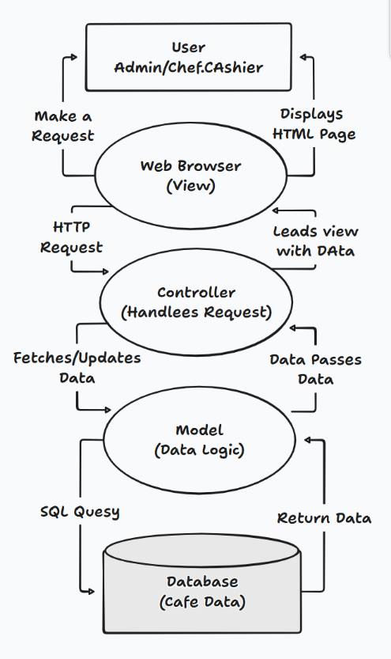
This MVC structure helps to keep the code clean, organized, and easy to manage.

6.1 Database Design
The database is the backbone of our project, where all the information is stored. We designed a simple and effective database schema with several tables to handle all the functionalities of the cafe.
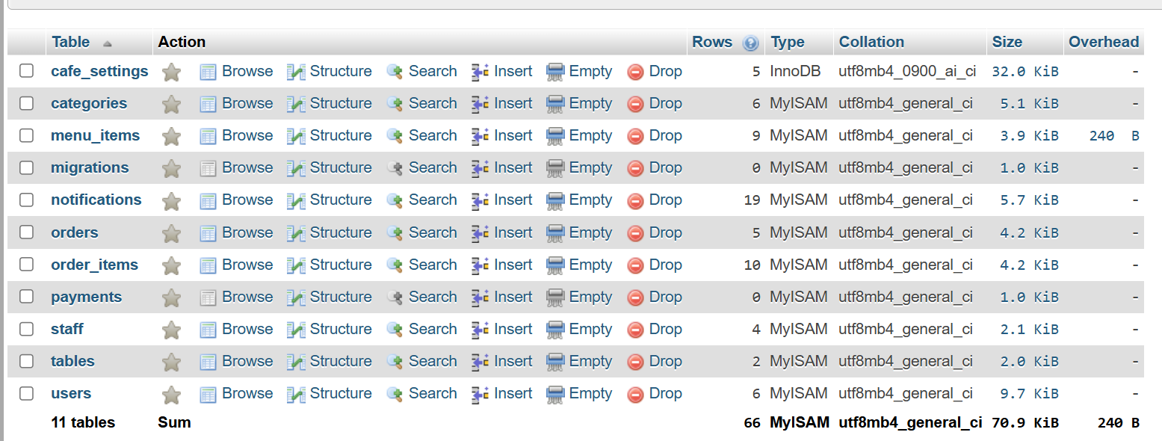
Here are the main tables in our database:
- users: This table stores the login details for all staff members, including their name, email, password (which is encrypted for security), and their role (admin, chef, or cashier).
- menu_items: This table contains all the food and beverage items available in the cafe. Each item has a name, price, an image, and a category_id to link it to a category.
- categories: This is a simple table to store the different menu categories, like 'Hot Coffee', 'Snacks', etc. This helps in organizing the menu.
- orders: This table keeps a record of every order placed in the cafe. It includes details like the table number, the total amount, and the current status of the order (e.g., Pending, Completed).
- order_items: This table stores the details of each order. It links the orders table with the menu_items table and stores which items were ordered, in what quantity, and the subtotal for each item.
- tables: This table holds information about all the tables in the cafe, including their name or number and their current status (e.g., Available, Occupied).
- staff: This table stores information about the staff members, like their name, role, and shift timings.
- notifications: This table is used for the real-time notification system. When a new order is placed, a notification is stored here for the admin and chef.
- cafe_settings: This table stores general settings for the cafe, such as its name, address, GST number, and contact details, which can be updated by the admin.
This database design ensures that all the data is well-organized and can be accessed efficiently by the application.

Chapter 7: Screenshots
Here are some screenshots of our Cafe Management System application, showing the main pages and features for different users.
1. Login Page This is the page where all staff members (Admin, Chef, and Cashier) can log in to the system.
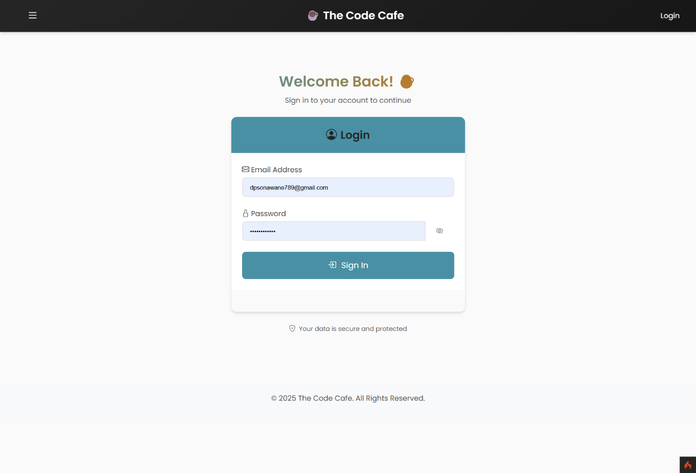

2. Admin Dashboard After logging in, the admin sees this main page. It shows a summary of today's sales, pending orders, total menu items, and available tables. It also has quick links to other management pages.
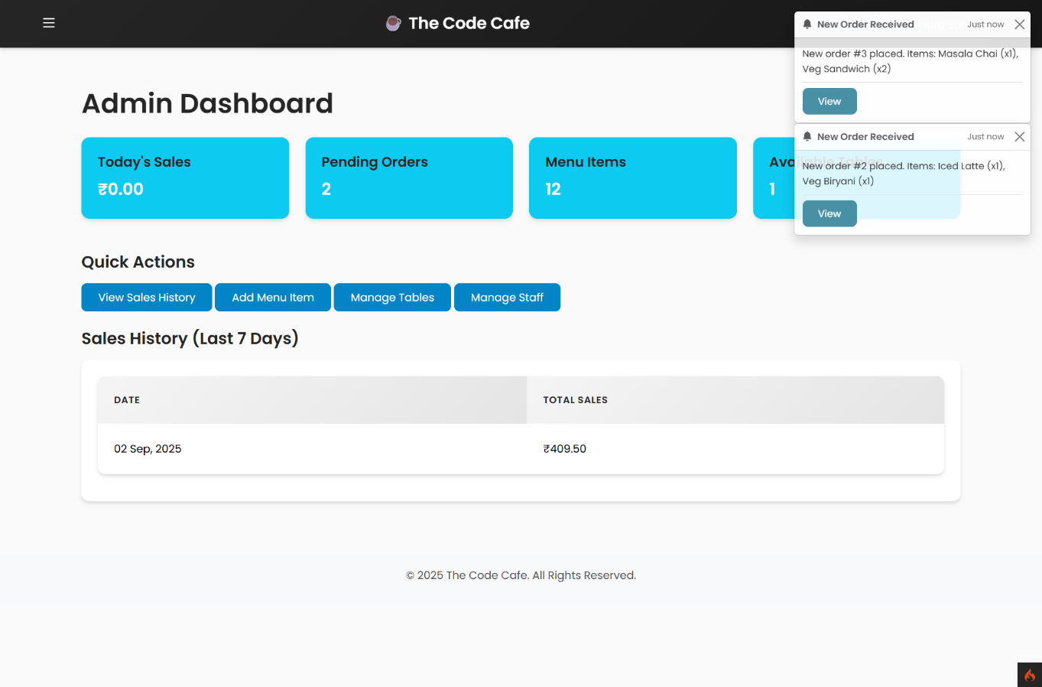

3. Menu Management Page (Admin) This screen allows the admin to see all the menu items. They can add a new item, edit an existing one, or delete an item from the menu.
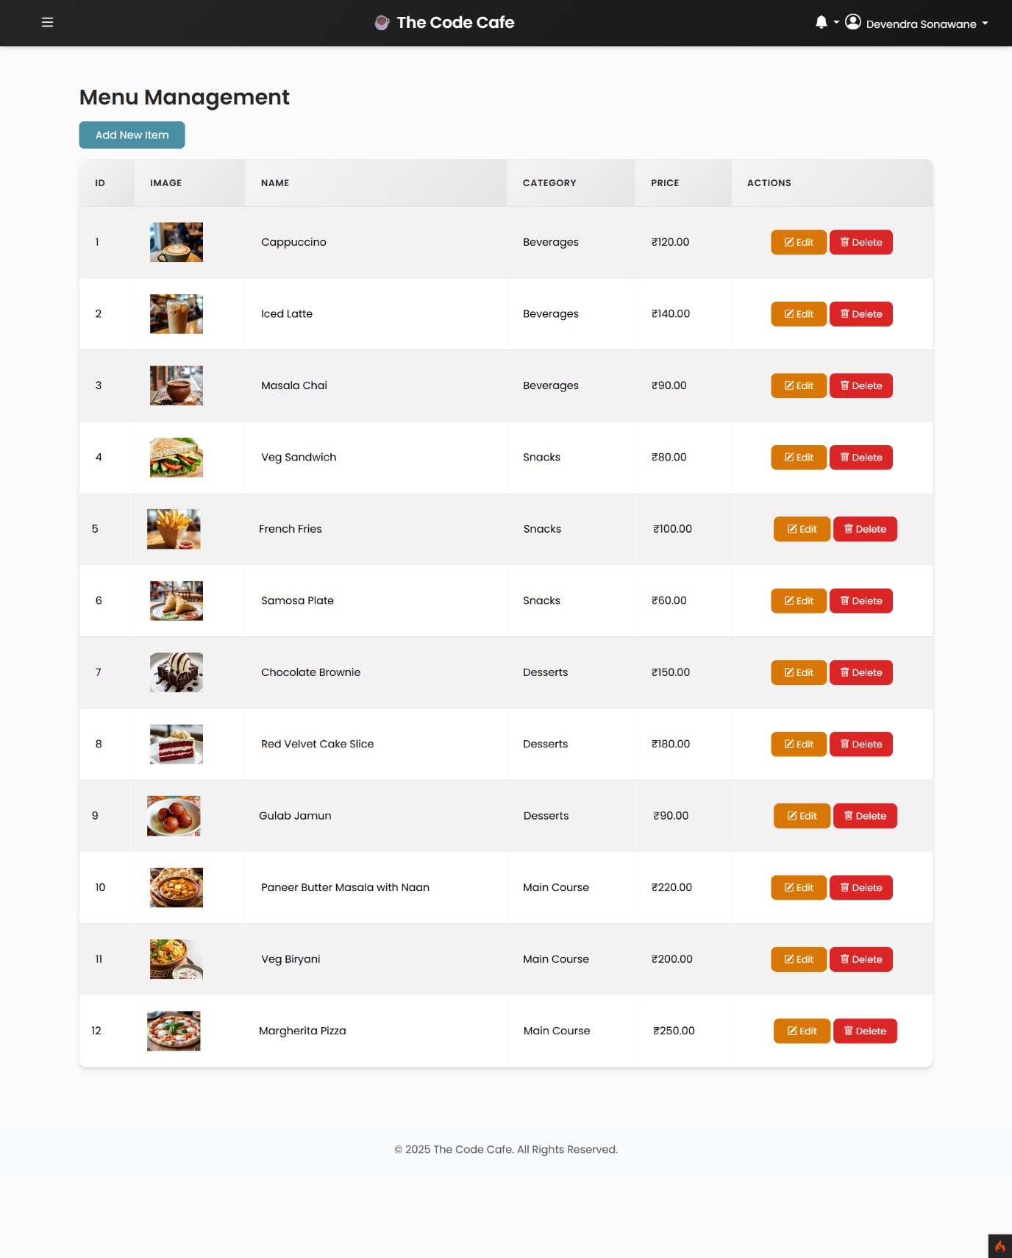

4. Order Management Page (Admin) Here, the admin can view all the orders that have been placed. They can see the order status and also have the option to view the bill or delete an order.
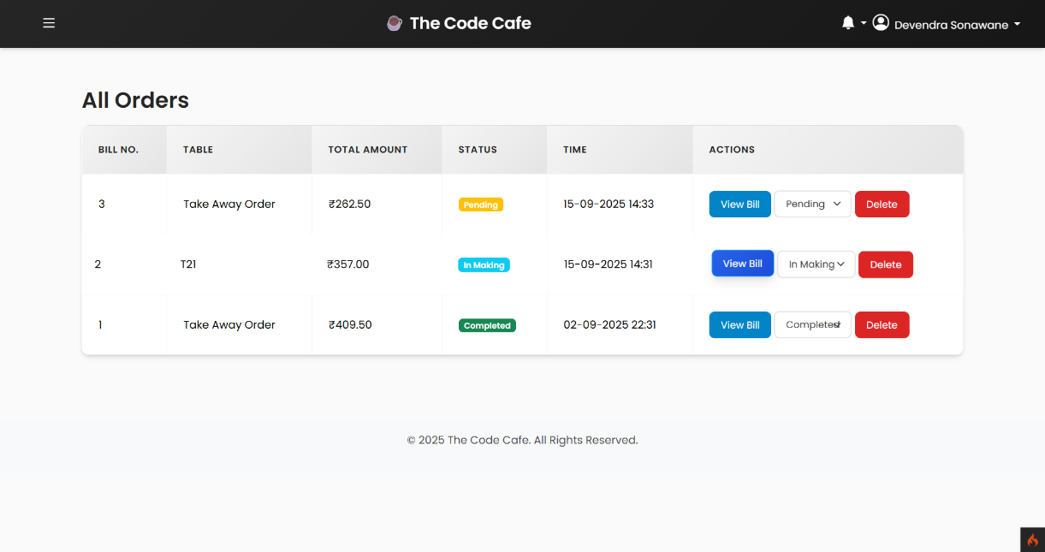

5. Chef's Dashboard This is the view for the chef. It shows all the new and ongoing orders in real-time so they know what to prepare. The chef can update the status of an order from 'Pending' to 'In Making' and then to 'Completed'.
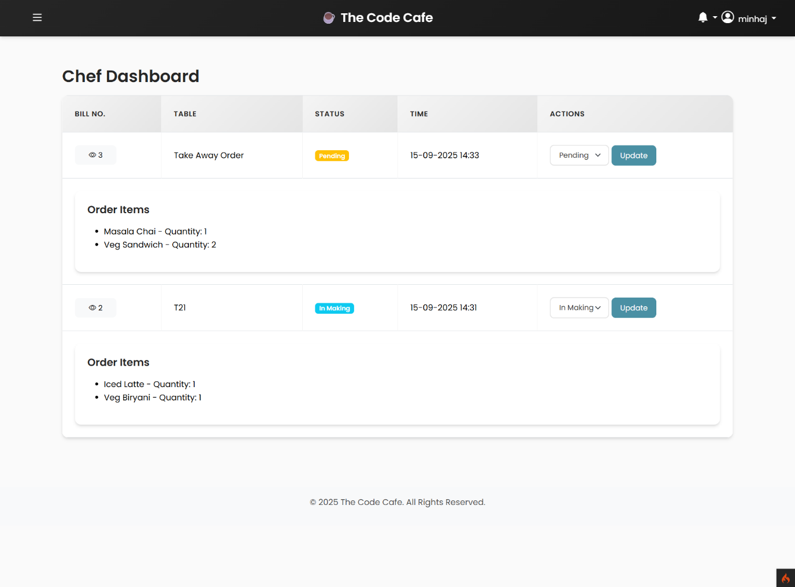

6. Cashier's Dashboard The cashier's main screen shows today's sales and the number of orders they have taken. The most important action here is the "New Order" button.
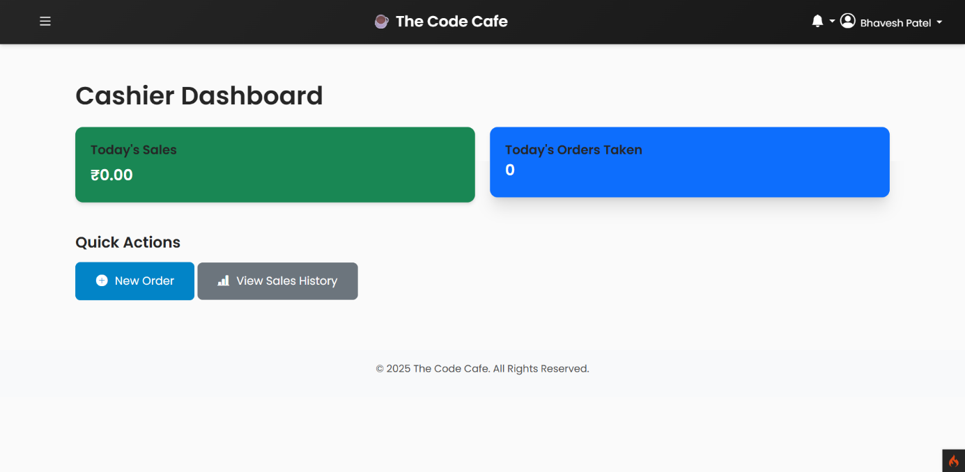

7. New Order Page (Cashier) This is the point-of-sale (POS) screen for the cashier. They can select items from the menu, add them to the cart, and place an order for either dine-in or take-away.
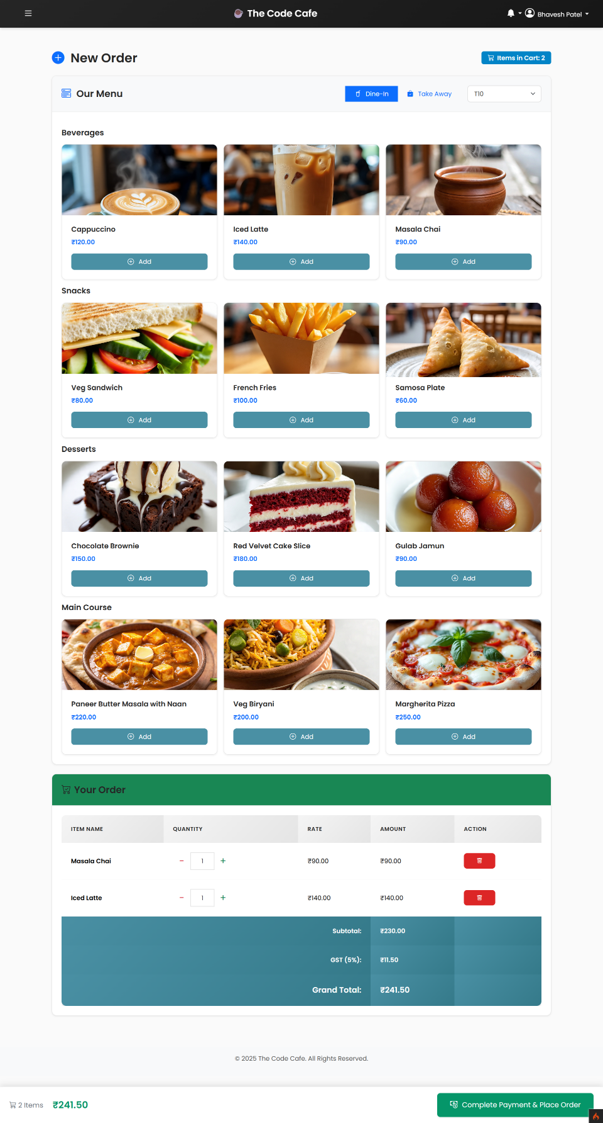
8. Customer's Order Page This is what a guest sees. They can browse the menu and add items to their cart to place an order.
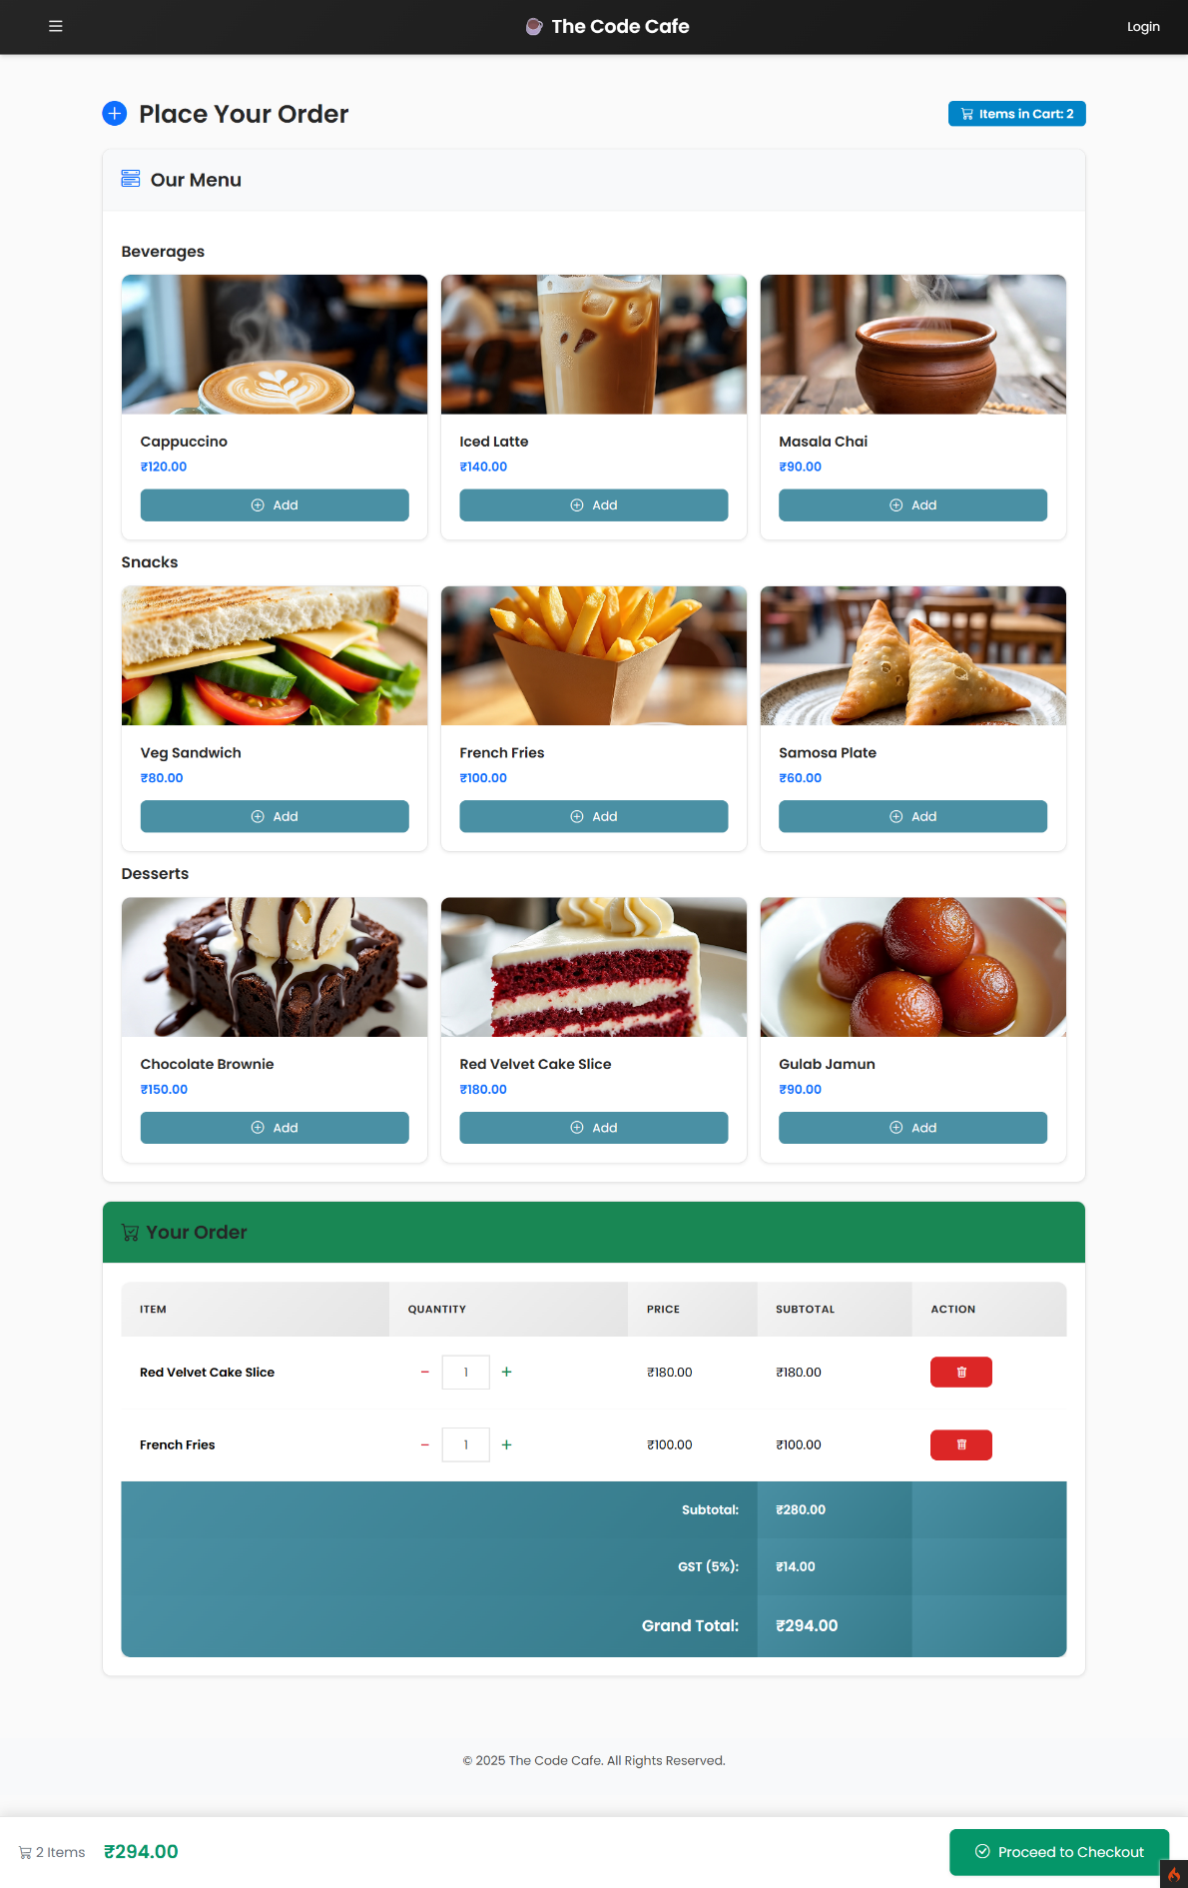
Chapter 8: Coding
For our project, we have followed the standard coding structure of the CodeIgniter 4 framework. All the code is neatly organized into different folders based on its function, which makes the project easy to understand and manage.
Here is a simple overview of our coding structure:
- app/Controllers/: This folder contains all the controller files. Controllers handle the user's requests and manage the flow of data. For example, UserController.php manages the login and logout functions, while MenuController.php handles all the logic for adding, editing, and deleting menu items.
e.g.: MenuCotroller.php
<?php namespace App\Controllers;

use App\Models\MenuModel;
use App\Models\CategoryModel;

class MenuController extends BaseController
{
public function index()
{
$model = new MenuModel();
$data['items'] = $model->select('menu_items.*, categories.name as category_name')
->join('categories', 'categories.id = menu_items.category_id', 'left')
->findAll();
return view('menu/index', $data);
}

public function new()
{
$categoryModel = new CategoryModel();
$data['categories'] = $categoryModel->findAll();
return view('menu/create', $data);
}

public function create()
{
$model = new MenuModel();

$img = $this->request->getFile('image');
$imgName = 'default.jpg'; // Default image
if ($img && $img->isValid() && !$img->hasMoved()) {
$imgName = $img->getRandomName();
$img->move('uploads/', $imgName);
}

$data = [
'name' => $this->request->getPost('name'),
'category_id' => $this->request->getPost('category_id'),
'price' => $this->request->getPost('price'),
'image' => $imgName
];

$model->save($data);
return redirect()->to('/admin/menu')->with('status', 'Menu Item Added Successfully');
}

public function edit($id = null)
{
$model = new MenuModel();
$categoryModel = new CategoryModel();
$data['item'] = $model->find($id);
$data['categories'] = $categoryModel->findAll();
return view('menu/edit', $data);
}

public function update($id = null)
{
$model = new MenuModel();
$data = [
'name' => $this->request->getPost('name'),
'category_id' => $this->request->getPost('category_id'),
'price' => $this->request->getPost('price'),
];

$img = $this->request->getFile('image');
if ($img && $img->isValid() && !$img->hasMoved()) {
$imgName = $img->getRandomName();
$img->move('uploads/', $imgName);
$data['image'] = $imgName;
}

$model->update($id, $data);
return redirect()->to('/admin/menu')->with('status', 'Menu Item Updated Successfully');
}

public function delete($id = null)
{
$model = new MenuModel();
$model->delete($id);
return redirect()->to('/admin/menu')->with('status', 'Menu Item Deleted Successfully');
}
}

e.g.: UserController.php
<?php namespace App\Controllers;

use App\Models\UserModel;
use App\Models\OrderModel;

class UserController extends BaseController
{
public function login()
{
// If the user is already logged in, redirect them to their dashboard
if (session()->get('isLoggedIn')) {
return redirect()->to(session()->get('role') === 'admin' ? '/' : '/user/dashboard');
}

return view('auth/login');
}

// In app/Controllers/UserController.php
public function authenticate()
{
$session = session();
$model = new UserModel();
$email = $this->request->getVar('email');
$password = $this->request->getVar('password');

$user = $model->where('email', $email)->first();

if (is_null($user)) {
return redirect()->back()->withInput()->with('error', 'Invalid email or password.');
}

// UPDATED ROLE CHECK
$allowed_roles = ['admin', 'chef', 'cashier'];
if (!in_array($user['role'], $allowed_roles)) {
return redirect()->back()->withInput()->with('error', 'Access denied.');
}

if (!password_verify($password, $user['password'])) {
return redirect()->back()->withInput()->with('error', 'Invalid email or password.');
}

$ses_data = [
'user_id' => $user['id'],
'name' => $user['name'],
'email' => $user['email'],
'role' => $user['role'],
'isLoggedIn' => TRUE
];
$session->set($ses_data);

// CORRECTED REDIRECT LOGIC
if ($user['role'] === 'admin') {
return redirect()->to('/admin/dashboard');
} elseif ($user['role'] === 'chef') {
return redirect()->to('/chef/dashboard');
} elseif ($user['role'] === 'cashier') {
return redirect()->to('/cashier/dashboard');
}

return redirect()->to('/login');
}

public function logout()
{
session()->destroy();
return redirect()->to('/login');
}
}

- app/Models/: This folder holds all the model files. Models are responsible for interacting with the database tables. For every table in our database, we have a corresponding model file. For instance, OrderModel.php is used to get order information from the orders table.
e.g.: OrderModel.php
<?php namespace App\Models;

use CodeIgniter\Model;

class OrderModel extends Model
{
protected $table = 'orders';
protected $primaryKey = 'id';
protected $returnType = 'array';
protected $allowedFields = ['table_id', 'user_id', 'total_amount', 'status', 'order_type'];
protected $useTimestamps = true;
protected $createdField = 'created_at';
protected $updatedField = '';

public function getOrdersWithDetails()
{
return $this->select('orders.*, tables.name as table_name')
->join('tables', 'tables.id = orders.table_id', 'left')
->orderBy('orders.created_at', 'DESC')
->findAll();
}

public function getOrderDetails($id)
{
return $this->select('orders.*, tables.name as table_name')
->join('tables', 'tables.id = orders.table_id', 'left')
->where('orders.id', $id)
->first();
}

public function getOrdersByUserId($userId)
{
return $this->select('orders.*, tables.name as table_name')
->join('tables', 'tables.id = orders.table_id', 'left')
->where('orders.user_id', $userId)
->orderBy('orders.created_at', 'DESC')
->findAll();
}
}

- app/Views/: This folder contains all the files that the user sees on their screen. These are the HTML pages of our project. We have used Bootstrap 5 to make them look good and work on all devices. For example, dashboard.php is the view file for the admin's main page.
- app/Config/: This is an important folder that contains all the configuration files for the project. The Routes.php file in this folder is very important as it defines all the URLs of our application and connects them to the correct controller functions. The Database.php file is used to connect our project to the MySQL database.
- public/: This is the main folder that is visible to the public. It contains the main index.php file, which is the starting point of the application. It also has folders for our CSS files, images, and any uploaded files (like menu item images).
- app/Database/Seeds/: This folder contains seeder files. We used a seeder file, CafeSeeder.php, to add some initial dummy data into our database tables, which helped us test the application easily.
By following this structure, we have kept our PHP code, HTML/CSS code, and database logic separate, which is a good practice in web development.

Chapter 9: References
This project was developed using a combination of modern and reliable web technologies. The primary references for our project were the official documentation of these technologies, along with various online tutorials and community forums.
Here are the main technologies and resources we used:
- Backend Framework:
  - PHP: The core programming language used for the backend logic.
    - Reference: https://www.php.net/manual/en/index.php
  - CodeIgniter 4: A powerful and lightweight PHP framework that provided the MVC structure for our application. The official CodeIgniter 4 User Guide was our main reference for this.
    - Reference: https://codeigniter.com/user_guide/
- Frontend Framework:
  - HTML5: Used for structuring the web pages.
  - CSS3: Used for custom styling and design.
  - Bootstrap 5: A popular CSS framework used to make our website responsive and look professional. We used its components like cards, tables, buttons, and forms.
    - Reference: https://getbootstrap.com/docs/5.0/getting-started/introduction/
- Database:
  - MySQL: An open-source relational database used to store all the application data.
    - Reference: https://dev.mysql.com/doc/refman/8.4/en/
- JavaScript:
  - We used plain JavaScript for client-side functionalities, such as updating the cart total in real-time and handling the pop-up notifications for new orders.

- Problem Solving help:
  - Google Gemini: https://gemini.google.com
  - ChatGPT: https://chatgpt.com
  - Claude AI: https://claude.ai/new

